Business Problem

In Recent Years, City Hotels and Resort Have Seen Higher Cancellation Rates. Each Hotel

Is Now Dealing With A Number Of Issues As A Result, Including Fewer revenues And Less Than Ideal Hotel Room Use. Consequently, Lowering Cancellation Rates Is Both Hotels

Primary Goals In Order To Increase Their Efficiency In Generating Revenue, And For Us To

Offer Through Business Advice to Address This Problem.

The Analysis Of Hotel Booking Cancellations As Well As Other Factors That Have No Bearing

On Their Business And Yearly Revenue Generation Are The Main Topics Of This Report.

Research Question

1. What are the variables that affect hotel reservation cancellations?
2. How can we make hotel reservation cancellations better?
3. How will hotels be assisted in making pricing and promotional decisions?

**Findings From Dataset**

**INSIGHT ON DATA:**

1. **66%** of Customers Choose The City Hotel For Reservation.  
2. Highly Hotel Reservation Arrival Month Are **[August, July, May, October, April, and June]**  Which is **60%** of Reservations.  
3. Most Likely Ordered Food By Customer is **BB** (77%) and Less Likely Food By Customer is **FB** (<1%).  
4. Maximum Customer Country is **PRT**(41%) and Others are **[GBR, FRA, ESP, and DEU]** (32%).  
5. Higher Rate Of Market Segment is Online (47%) and From Offline (20%).  
6. Most Likely Distribution Channel is **TA/TO** (82%).  
7. Customer Highly Choose Room Type **A** (72%).  
8. Check Out Percentage Of Total Reservation is (63%) And the Cancelled Rate is (36%).

***Data Visualization:***

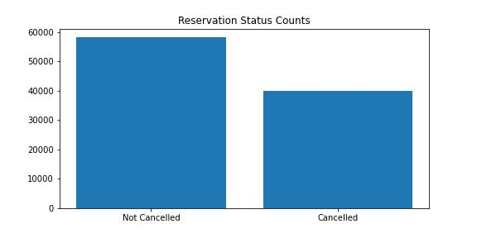

The accompanying bar graph shows the percentage of reservations that are cancelled and those that are not. It is obvious that there are still a significant number of reservations that have not been cancelled. There are still 37% of clients who cancelled their reservations, which has a significant impact on the hotel’s earnings.

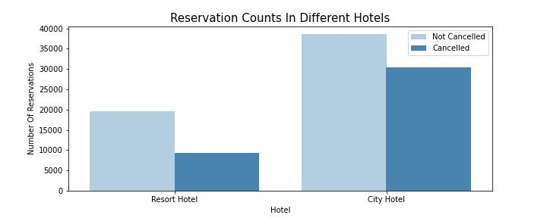

High reservations come from city hotels rather than resort hotels.

In Resort Hotels Reservation Ratio is High compared to City Hotel. Because The Cancellation Rate Is High In City Hotels compared to Resort Hotels. In Resort Hotels confirm reservation rate is 68% and the Cancelled rate is 32%. In City Hotels confirm reservation rate is 56% and the cancelled rate is 44%. Which indicates that higher revenue comes from resort hotels.

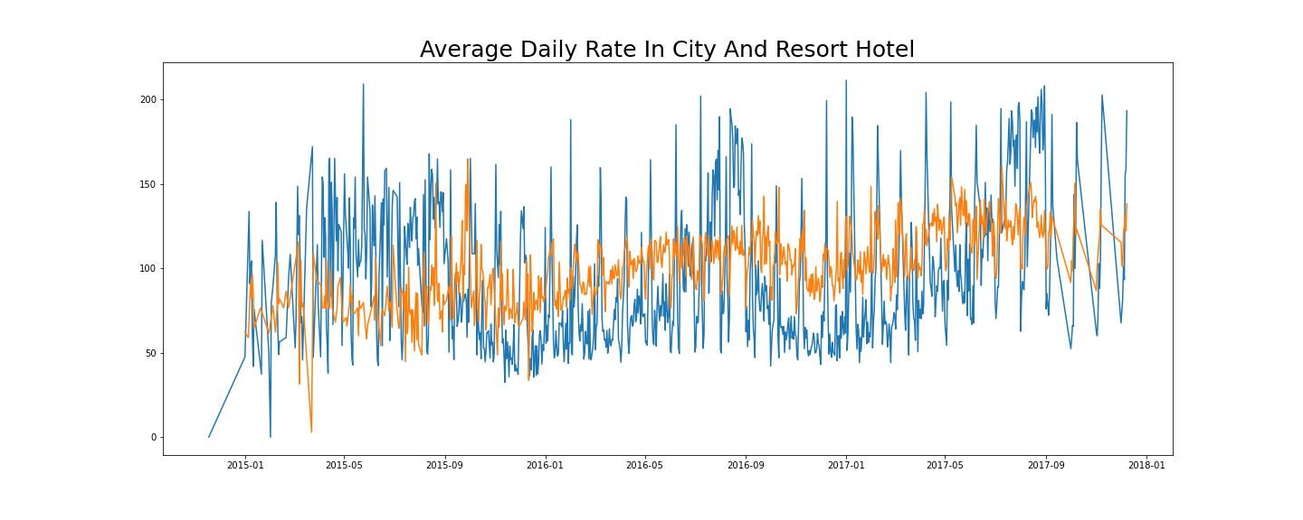

The line graph above shows that, on certain days, the average daily rate for a city hotel is less than that of a resort hotel, and on other days, it is even less. It goes without saying that weekends and holidays may see a rise in resort hotel rates.

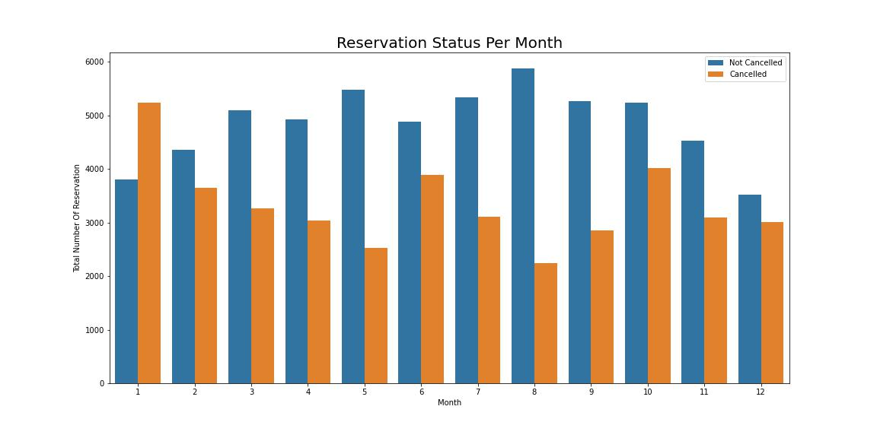

We have developed the grouped bar graph to analyze the months with the highest and lowest reservation levels according to reservation status. As can be seen, both the number of confirmed reservations and the number of cancelled reservations are the largest in the month of August. Whereas January is the month with the most cancelled reservations.

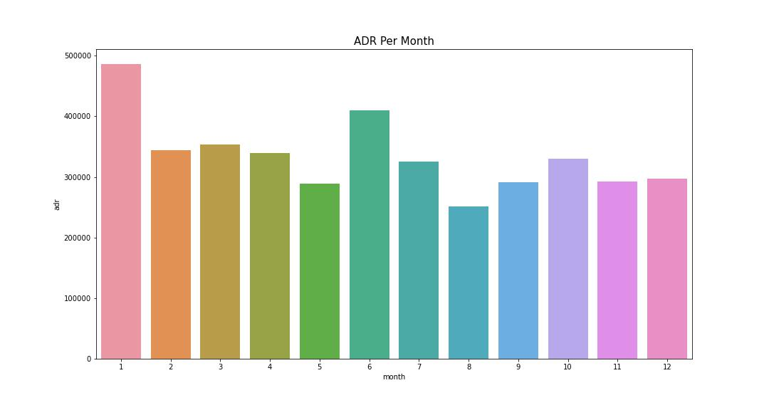

This bar graph demonstrates that cancellations are most common when prices are greatest and are least common when they are lowest. Therefore, the cost of the accommodation is solely responsible for the cancellation.

Now, let’s see which country has the highest reservation cancelled. The top country is Portugal with the highest number of cancellations.

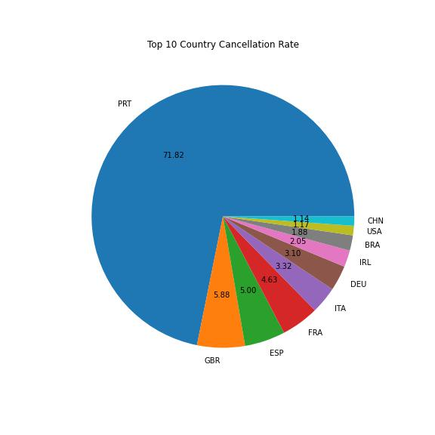

Let’s check the area from where guests are visiting the hotels and making reservations. Is it coming from Direct or Groups, online or Offline Travel Agents?

Around 46% of the clients come from online travel agencies, whereas 27% come from groups. Only 4% of clients book hotels by visiting them and making reservations.

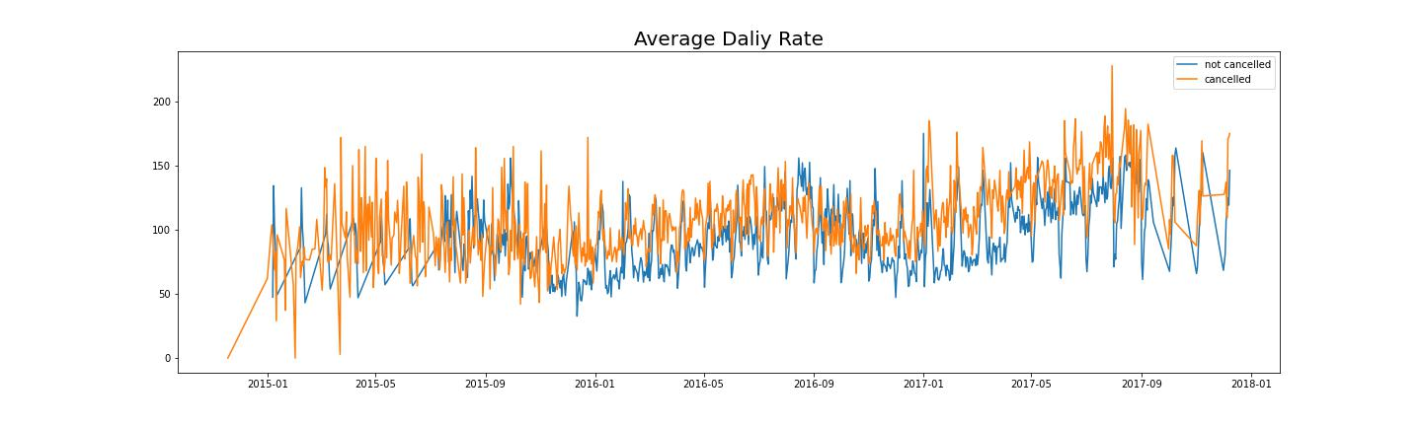

As seen in the graph, reservations are cancelled when the average daily rate is higher than when it Is not cancelled. It clearly proves all the above analysis, that the higher price leads to higher cancellations.

***Suggestions:***

1. Cancellation rates rise as the price does. In order to prevent cancellations of reservations, hotels could work on their pricing strategies and try to lower the rates for specific hotels based on locations. They can also provide some discounts to the consumers.
2. As the ratio of the cancellation and not cancellation of the resort is higher in the resort hotel than in the city hotels. So the hotels should provide a reasonable discount on the room prices on weekends or on holidays.
3. In the month of January, hotels can start campaigns or marketing with a reasonable amount to increase their revenue as cancellation is the highest in this month.
4. They can also increase the quality of their hotels and their services mainly in Portugal to reduce the cancellation rate.